GIT IMPORTANT COMMANDS

CONFIGURATION
git config --global user.name "___"
git config --global user.email "_____"

CLONING A FOLDER
git clone https link of file

TO CHECK THE STATUS OF THE FILE
git status

ADD CHANGES
git add filename -----individually adding
git add . ----adding all the changes

COMMIT CHANGES
git commit -m "some message"

TO SEE THE CHANGES ON GITHUB
git push origin main

TO CREATE A NEW GIT REPO USING VS CODE:

init- used to create a new git repo

git init
git remote add origin <link>
git remote -v (to verify remote)
git branch (to check branch)
git branch -M main (to rename branch)
git push origin main

BRANCH COMMANDS

git branch (to check branch)
git branch -M main (to rename branch)
git checkout <branch name> (to navigate)
git checkout -b <new branch name> (to create new branch)

git branch -d <branch name> (to delete branch)--------cannot delete a branch if you are already
in it, first checkout from that branch and
then, delete.

MERGING CODES OF DIFFEREN BRANCHES INTO THE MAIN BRANCH

WAY 1: git diff <branch name> (to compare commits, branches, files & more)
git merge <branch name> (to merge two branches)

WAY 2:
Create a PR. (Pull Request) ---It lets you tell others about the changes you’ve pushed to a branch in a branch in GitHub.

PULL COMMAND
git pull origin main------(used to fetch and download content from a remote repo and immediately
update the local repo to match that content).

RESOLVING MERGE CONFLICTS
An event that takes place when GitHub is not able to automatically resolve differences in code between 2 commits.
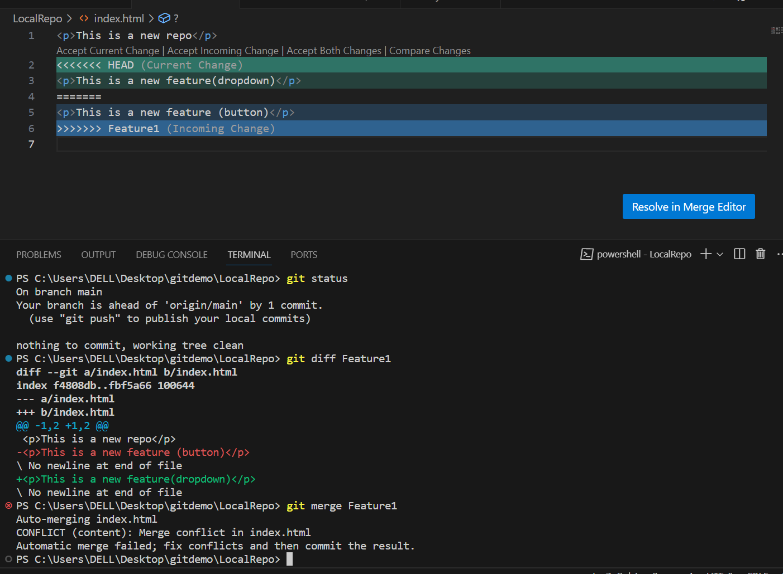

UNDOING CHANGES
CASE 1: Staged Changes
git reset <file name>
git reset

CASE 2: Committed Changes (for 1 commit)
git reset HEAD~1

CASE 3: Committed Changes (for many commits)
git reset <commit hash> (type git log, and copy the hash of the commit to which you
want to reset the commits) (changes only get reset in GitHub)
git reset --hard <commit hash> (commits get reset from VS code as well as GitHub)

TO CHECK THE COMMITS IN VS CODE:
git log
(Press q to end the log and continue writing in the terminal)

FORK
A new repository that shares code and visibility settings with the original “upstream” repository.
Fork is a rough copy.

